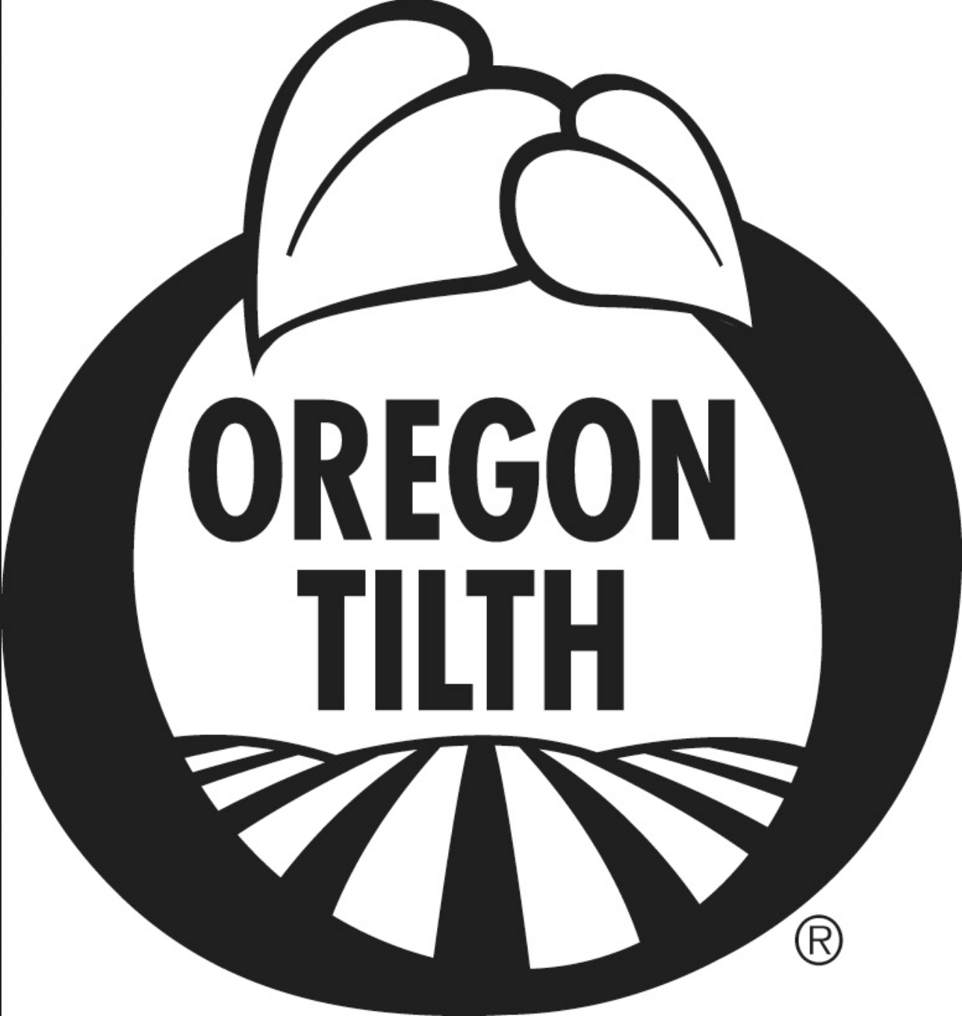 | Certified Grass-Fed Organic Product Plan | 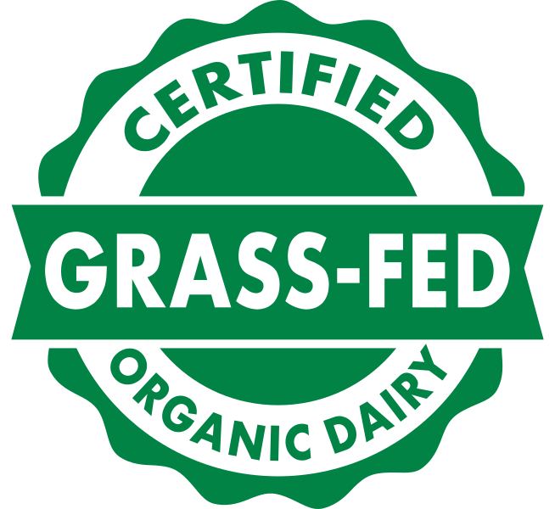OPT-P
 | Electronic versions available at www.tilth.org Page 1 of 5

Operation Name: |  | Date:
► Use this form if you are requesting certification to the Certified Grass-Fed Organic Livestock Program. To qualify for this certification you must be currently certified organic with OTCO, or simultaneously submit an application for organic certification and an application for this Program. OTCO will assess compliance to the OPT Certified Grass-Fed Organic Program using the USDA National Organic Program as the base level of compliance.
► Submit this completed form along with payment for services. Annual fees for addition of this standard are $350.

  - GENERAL INFORMATION
Oregon Tilth will review your Organic System Plan to verify compliance to this Standard. List below the names of products to be Certified Grass-fed Organic. The listing below must match the products listed on your Master Ingredient List (Form MIL-03). Attach additional sheets as necessary.

Name of Product as it will be sold (include varieties) | Brand Name | Specify intended labeling category
Certified Organic grass-fed (>95%)
Contains OG grass-fed ingredients*(>70%)

Certified Organic grass-fed (>95%)
Contains OG grass-fed ingredients*(>70%)

Certified Organic grass-fed (>95%)
Contains OG grass-fed ingredients*(>70%)

Certified Organic grass-fed (>95%)
Contains OG grass-fed ingredients*(>70%)

Certified Organic grass-fed (>95%)
Contains OG grass-fed ingredients*(>70%)

* In no case shall a multi-ingredient product combine “Certified Grass-Fed Organic [product class]” ingredients and non- grass-fed certified forms of the same ingredient.

  - GENERAL FACILITY INFORMATION
List all facilities that process and/or handle Certified Grass-Fed Organic products. The listing below must match the facilities included in your Organic System Plan H2 Facility Information.

Facility Names | City, State

  - LABELING
All Certified Grass-Fed Organic labels must first meet Organic labeling guidelines, with the following additional requirements:
- Single and multi-ingredient products composed of dairy or meat produced by, or derived from, animals on operations certified to this program shall be labeled: “Certified Grass-Fed Organic Dairy [product]” or “Certified Grass-Fed Organic Meat [product].”
- Multi-ingredient products containing livestock ingredients certified to this program’s requirements shall be labeled in accordance with the labeling content classification system used in the federal organic program and the placement of the above referenced labeling language shall be applied analogously to the use of the word “organic” under the NOP. See 7 C.F.R. §§301-305.
- If a multi-ingredient product is composed of 70%-94% ingredients compliant with this program it may be labeled “Contains Certified Grass-Fed Organic [ingredient described]” provided, the remaining content of the product must comply with organic requirements and in no case shall it contain the same ingredient certified to this program’s standard and a portion not certified to this program’s standard.
- Agricultural products that are OPT Grass-Fed Certified shall include the following statement below the information identifying the handler/distributor: “OPT Grass-Fed Organic Certified by Oregon Tilth”

- Attach all labels with application.
Attached No labels used I will submit prior to printing for review.

- Do you own the final labels of the finished Grass-Fed Organic products being produced at your facility?
Yes No
If yes, and you use the Grass-Fed Organic Seal, do you have a licensing agreement in place with the OPT Program Manager? Yes No, If no, explain:

  - RECEIVING
OTCO will assess compliance to the OPT Certified Grass-Fed Organic Program using the USDA National Organic Program as the base level of compliance. Practices as described in the Organic System Plan H6 Receiving, Storage, Packaging and Shipping will be used to determine compliance with this program unless you have specified that Grass-Fed Organic Products are treated differently.

Do you ever receive grass-fed and non grass-fed products (milk, meat etc.) at the same time or in the same vehicle?

No Yes
If yes, what steps are taken to prevent commingling of grass-fed and non grass-fed products?
Labeled pallets Product sealed or shrink wrapped Designated areas
Other, describe:

- Do you receive products in reusable containers/vehicles (e.g. plastic containers, tankers, railcars)?
No Yes
If yes, describe how cleaning practices, and materials used, for incoming containers/vehicles are verified to be compliant.
NOTE: You may need to request this information from the supplier or transportation company. Attached

- Are there any receiving practices used for Grass-Fed Organic products that are in addition to or different than those described in your Organic System Plan H6 Receiving, Storage, Packaging and Shipping.
No Yes
If yes, describe below:

STORAGE
OTCO will assess compliance to the OPT Certified Grass-Fed Organic Program using the USDA National Organic Program as the base level of compliance. Practices as described in the Organic System Plan H6 Receiving, Storage, Packaging and Shipping will be used to determine compliance with this program unless you have specified that Grass-Fed Organic Products are treated differently.

- How do you ensure Grass-Fed Organic products are not commingled with non grass-fed products in storage?
Not applicable, all products are Grass-Fed Organic All products sealed and labeled
Storage areas dedicated and identified as Grass-Fed Organic
Other:

- How do you prevent commingling of outgoing grass-fed products?
Grass-ed never shipped with non grass-fed Clearly labeled packages/pallets
Product sealed or shrink wrapped
Separate areas in vehicle Other:

- Are there any storage practices used for Grass-Fed Organic products that are in addition to or different than those described in your Organic System Plan H6 Receiving, Storage, Packaging and Shipping.
No Yes
If yes, describe below:

LOCATION OF RECORDS
OTCO will assess compliance to the OPT Certified Grass-Fed Organic Program using the USDA National Organic Program as the base level of compliance. Practices as described in the Organic System Plan H8 Recordkeeping will be used to determine compliance with this program unless you have specified that Grass-Fed Organic Products are treated differently.

  - Is the location of records for Grass-Fed Organic Certification the same as the location listed on the Organic System Plan H8, Recordkeeping.
Yes No, complete address below:
Site Address: |  | Country:
City: | State: | Zip:
Contact Name: | Title:
Phone: | Fax:
Email(s):
TRACKING GRASS-FED ORGANIC PRODUCTS
OTCO will assess compliance to the OPT Certified Grass-Fed Organic Program using the USDA National Organic Program as the base level of compliance. Practices as described in the Organic System Plan H8 Recordkeeping will be used to determine compliance with this program unless you have specified that Grass-Fed Organic Products are treated differently. You must ensure that only OPT certified or recognized grass-fed certifications are used within any product sold under this standard.

2) Identify suppliers of Grass-Fed Organic raw material and how you will verify ongoing certification under these standards.
Attach separate sheets as necessary.
Supplier Name | Grass-Fed Organic Certifier | Grass-Fed Certificate
 |  | Attached
 |  | Attached
 |  | Attached
 |  | Attached
 |  | Attached

3) Is your method of tracking finished products from ingredient purchasing through production or packing to final outbound
shipping or invoice for Grass-Fed Organic products the same as described in your Organic System Plan H8 Recordkeeping
Practices?
Yes No
If no, describe or attach a diagram of how your audit trail/trace-back system tracks finished products from ingredient purchasing through production or packing to final outbound shipping or invoice. Diagram attached
    - You may attach sample documents (BOLs, packing slips, inventory logs, batch records) to demonstrate your audit trail system.
Records attached Product Recall System attached

- Are records and the system used to track inventory of ingredients and products (in/out balance) for Grass-Fed Organic products the same as described in your Organic System Plan H8 Recordkeeping Practices.
Yes No
If no, describe or attach a diagram of how your audit trail/trace-back system tracks finished products from ingredient purchasing through production or packing to final outbound shipping or invoice. Diagram attached
a) You may attach samples to illustrate (i.e. monthly log of beginning and ending inventory).
Records attached

LOT NUMBERING
OTCO will assess compliance to the OPT Certified Grass-Fed Organic Program using the USDA National Organic Program as the base level of compliance. Practices as described in the Organic System Plan H8 Recordkeeping will be used to determine compliance with this program unless you have specified that Grass-Fed Organic Products are treated differently.

Is your lot numbering system for finished Grass-Fed Organic products the same as described in your Organic System Plan H8 Recordkeeping Practices?
Yes No
If no, describe below:
EXAMPLE: Lot Number: 0123A045
Code | 0 | 123 | A | O | 45
Signifies | Year: 2000 | Julian date :production | Shift | Organic | Plant location

Lot Number:
Code
Signifies

- How is your lot number associated with outgoing shipments?
On invoice or Bill of Lading On a “pick list” or “ship list”
Other:

By signing below, I am authorizing Oregon Tilth to conduct the assessment and review to the OPT Grass-fed Organic Certification Standards for my operation. I further agree to the following:

- I am authorized to act on behalf of the company and affirm that all information represented here and within the Organic System Plan are an accurate account and full representation of all materials and methods used in the production of grass-fed organic certified products.
- I agree to maintain records as required to demonstrate compliance with the Standards and to make those records available to Oregon Tilth upon request. Including, but not limited to results of any quality control program.
- I confirm that I have reviewed the Standards and am familiar with the certification process including the process for noncompliance and corrective actions. I understand that unsanctioned actions and willful violations of the Standards may result in denial of my certification application or suspension or termination of my certification.

Signature: |  | Date:
Printed Name:

