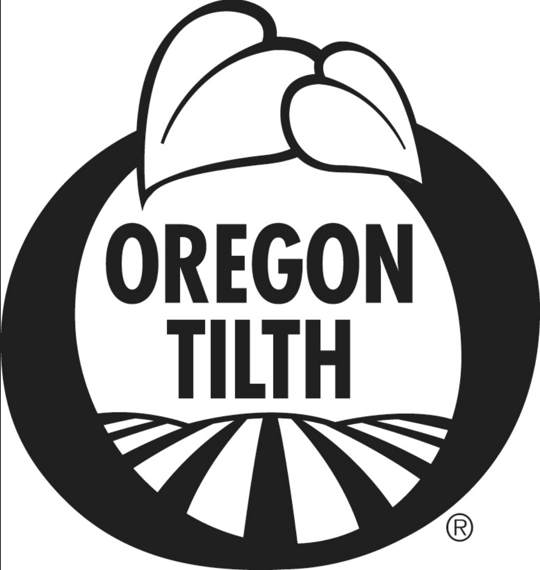 | Certified Grass-Fed Organic Livestock Plan | 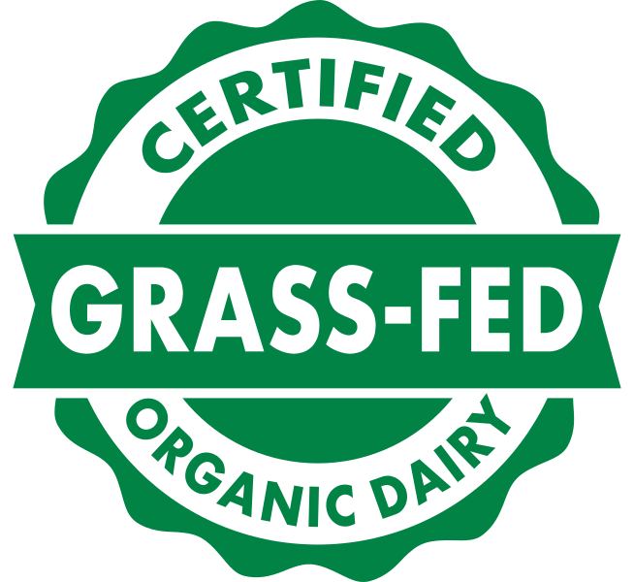  OPT-L
 | Electronic versions available at www.tilth.org Page 1 of 6

Operation Name: |  | Date:
► Complete and submit this form for OTCO to assess your operation’s compliance to the OPT Certified Grass-Fed Organic Livestock Program using the USDA National Organic Program as the base level of compliance. To qualify for this program you must be either currently certified organic by or have submitted an application for organic certification to Oregon Tilth.
► Submit this completed form along with payment for services. Annual fees for addition of this standard are $350.

Products requested for grass-fed certification:
Grass-Fed Organic dairy animal production Grass-Fed Organic meat animal production
Species of animals described by this form:
Cattle Sheep Goats Other:

- QUALIFICATION FOR GRASS-FED CERTIFICATION
OPT II To qualify for Grass-Fed Organic certification, operations must be certified organic and certified by an animal welfare program approved in the OPT Program Manual. In addition, OTCO will verify that all animals being milked at the operation, or at any single site of a multi-site operation, are solely certified Grass-Fed Organic. Livestock for Grass-Fed Organic meat production may exist on the same farm as animals not intended for Grass-Fed production, as long as segregation and records are in place to demonstrate compliance.

- Are you currently certified organic with Oregon Tilth?
Yes No
If no, are you applying for organic certification with Oregon Tilth? Yes No

- Are you currently certified with an animal welfare program?
Yes, indicate which program:
No, If no, are you applying for certification with an animal welfare program?
Yes, indicate which program:
When is certification expected:

- Have you ever had a negative scoring report from an animal welfare inspection?
No Yes, attached is a copy of the report and the written response mitigating any findings.
N/A

For dairy animals only-

All of my dairy animals are requested for Grass-Fed Organic certification.
I raise both Grass-Fed Organic and non Grass-Fed Organic dairy animals. Note: All lactating animals at a single site must be certified Grass-Fed Organic. Indicate the address(es) where Grass-Fed Organic animals are raised:
Address:
For meat animals only-
All of my meat animals are requested for Grass-Fed Organic certification.
I raise OPT, NOP, and/or Conventional meat animals at a single site. Note: A segregation plan must be in place to keep OPT, NOP, and/or Conventional meat animals physically separated.

- ORIGIN OF GRASS-FED LIVESTOCK
OPT III Any ruminant animal, certified to the Grass-Fed Organic Standard, shall have been maintained under this Standard throughout its life. If a dairy animal meeting those requirements is not commercially available, animals may only be purchased from a certified organic operation and a 90-day transition period is required. Ruminants for meat production may not transition at any point as defined by this Standard.

- When did you begin (or plan to begin) grass-fed livestock management (includes grazing and feed requirements, organic and welfare certification)? Month/Day/Year:
- Attach a complete list of animals requested for Grass-Fed Organic Certification. List attached
- Animals requested for certification under this Standard were:
Born on this operation requested for certification
Purchased from a farm that is certified to this Grass-Fed Organic standard
For dairy animals only –
Purchased from a certified organic operation and transitioned for 90 days, during which time their milk was not labeled or represented as Grass-Fed Organic. Ensure commercial availability documentation is attached, if applicable.
Note: animals must be purchased from a certified Grass-Fed Organic operation, unless it can be demonstrated that animals certified to the Grass-Fed Organic standard were not commercially available.

- GRASS-FED LIVESTOCK FEED
OPT IV – VI requires that animals graze throughout the entire grazing season, which shall be not less than 150 days and provide not less than 60 percent of an animal's dry matter intake (DMI) from grazing throughout the grazing season. The grazing season may or may not be continuous. A weaned animal’s diet may be supplemented when necessary to maintain nutritional stability and optimal rumen welfare with the following plant-based feedstuffs as listed below.

- The Oregon Tilth form L3R Livestock Feed & Water- Ruminant requests feed sources and rations for each production group (calves, milk cows, ewes, etc.) that you managed during the grazing and non-grazing seasons as indicated. In the following section, confirm the answers provided on those forms are in compliance with each requirement. If you raise both Grass-Fed Organic animals. All boxes in this section must be checked.
I confirm that…..
The L3R Livestock Feed & Water form on file with Oregon Tilth is complete and accurate for Grass-Fed Organic animals requested for certification.
Animals are grazed more than 150 days per calendar year.
Grazing provides not less than 60 percent of each animal’s dry matter intake (DMI) averaged throughout the grazing season.
I have attached dry matter intake worksheets for each class of animal
Animals graze forage comprised of annual and perennial grasses, legumes, forbs, brassicas, and browse; and grazed vegetative-stage cereal grain plants (corn in a pre-tassel stage, soybeans prior to bloom; small and cereal grains pre-boot stage); and harvested forages and harvested vegetative-stage cereal grain crops (corn in a pre-tassel stage, soybeans prior to bloom; small and cereal grains pre-boot stage).

2) A weaned animal’s diet is supplemented when necessary to maintain nutritional stability and optimal rumen welfare with the following plant-based feedstuffs as listed below. Check all that apply.
I feed forage in cube or pellet form with a daily limit of not more than 6lbs or ≤0.5% of the animal’s body weight.
I feed certified organic beet and citrus pulp, certified organic sugar cane in liquid molasses and dry form provided it is strictly limited to supplemental amounts as set forth in the OPTs Program Manual and only one source is fed per day.
I feed forage grown in fodder sprout systems. Consumption is limited to 1.75% of an animal’s body weight and not more than 20 lbs. per day. Sprout roots are removed prior to feeding and it is fed solely during the non-grazing season.
I feed vitamins and minerals specifically permitted in organic production that are free of grain and grain carriers as required to maintain animal, rumen and nutritional health.

3) Limited Exceptions to this Standard’s Livestock Diet Composition Requirements
Complete only if applicable. If section is not applicable check here NA
If it is determined that an animal's health is compromised, I will temporarily disregard the volume restrictions on grain-free supplemental feedstuffs described in the “Allowed but Restricted Grain-Free Feedstuffs” section, until the animal’s health is restored. I understand that documentation must either be a record produced by a licensed veterinarian, or a determination made by a responsible person at the certified operation. Supporting records must be indicative of substandard health and verified by the certifying body, (e.g. abnormal growth pattern or declining body score, unusual decline in milk production, abnormal maternal instincts etc.) Records of ration changes must be maintained and available for your Inspector.

4) Prohibited feed and feeding practices The following box must be checked
I DO NOT feed any grains and grain by-products (including but not limited to corn, soybean, small grains and distillers grain), concentrates, meals, pelleted feed, or any other non-forage-based feedstuff not expressly allowed under this Program.

5) Disqualified animal affirmations All of the following boxes must be checked
I understand that any animal intentionally fed disallowed feedstuffs or that inadvertently receives more than de minimis amounts of prohibited feedstuffs or feed products is permanently disqualified from this program and I will notify Oregon Tilth of any such disqualifications.

I understand that if a dairy animal receives disqualifying feed I have 10 calendar days to provide notice to Oregon Tilth. Note you may contact the Oregon Tilth to supply this information (503) 378-0690 email organic@tilth.org

I understand that I have 7 calendar days after receiving the formal disqualification notice from the certifying body (Oregon Tilth) to remove the animal from the Grass-Fed Organic dairy. Meat animals may be placed within an organic herd at the operation if a split operation is maintained.

I understand that during the 7-day period following disqualification and before removal of the animal from the operation, any milk obtained from the disqualified animal shall be segregated from milk from compliant animals and an animal-specific log shall be maintained that records the amount of milk obtained and the manner by which its segregation is ensured.

I understand that I have 10 calendar days after the dairy animal has been removed from the Operation to provide to Oregon Tilth the milk segregation log, and/or a signed statement verifying the removal of the disqualified animal(s) and identifying the recipient of the animals.

- GRASS-FED LIVESTOCK HEALTHCARE
OPT VII requires that operations must participate in an animal welfare verified program that includes on-site inspections and that is approved by this Program in accordance with terms more fully set forth in the Program Manual.

The L4 Livestock Healthcare plan submitted with my Oregon Tilth Organic System Plan is complete and includes all information pertaining to Grass-Fed Organic livestock.

- GRASS-FED LIVESTOCK LIVING CONDITIONS
OPT VIII To maintain certification under the OPT Standards operations must meet the National Organic Programs, provided that, in no case shall bedding include prohibited feed products under this Standard.

The bedding used for my grass-fed livestock DOES NOT consist of prohibited feed products under this Standard.

The L5M Livestock Living Conditions (mammals) plan submitted with my Oregon Tilth Organic System Plan is complete and includes all information pertaining to Grass-Fed Organic livestock.

- GRASS-FED LIVESTOCK PASTURE MANAGEMENT PLAN
OPT IX Each operation certified to this Standard must meet all applicable requirements of the National Organic Program and includes practices that allow for pasture rest, regrowth and prevents over grazing.

The L6 Pasture Management plan submitted with my Oregon Tilth Organic System Plan is complete and includes all acreage used for grazing grass-fed livestock.

- GRASS-FED PRODUCT PROCESSING
OPT XI Any handling operation, or portion thereof, that handles agricultural products certified under this Standard shall maintain a Standard Operating Procedure that sets forth the practice standards by which products
certified to this Standard are properly handled, segregated and not commingled with products not certified to this Standard.

The L7 Product Processing form on file with Oregon Tilth is complete and includes all information pertaining to grass-fed livestock products.

- GRASS-FED LIVESTOCK RECORDKEEPING
OPT X Although the OPT Grass-Fed Organic program imposes additional record keeping requirements, (e.g. grazing, limitations on grain in feedstuffs, supplements, feed additives, vitamin products, disposition of non-compliant animals and milk, and split-operations), the purpose, form, and substance of recordkeeping is identical to that required for organic certification.

The L9 Livestock Recordkeeping form on file with Oregon Tilth is complete and includes all information pertaining to grass-fed organic livestock.

- GRASS-FED LIVESTOCK LABELING
OPT XII All Certified Grass-Fed Organic labels must first meet Organic labeling guidelines, with the following additional requirements:
- Single ingredient products composed of dairy or meat produced by, or derived from, animals on operations certified to this program shall be labeled: “Certified Grass-Fed Organic Dairy [product]” or “Certified Grass-Fed Organic Meat [product].”
- Multi-ingredient products containing livestock ingredients certified to this program’s requirements shall be labeled in accordance with the labeling content classification system used in the federal organic program and the placement of the above referenced labeling language shall be applied analogously to the use of the word “organic” under the NOP. See 7 C.F.R. §§301-305.

- Attach all labels with application.
Attached No labels used Will submit prior to printing for review.

By signing below, I am authorizing Oregon Tilth to conduct the assessment and review to the Certified Grass-Fed Organic Standards for my operation. I further agree to the following:

- I am authorized to act on behalf of the company and affirm that all information represented here and within the Certified Grass-fed Organic Livestock Plan are an accurate account and full representation of all materials and methods used in the production of certified products.
- I agree to maintain records as required to demonstrate compliance with the Standards and to make those records available to Oregon Tilth upon request. Including, but not limited to results of any quality control program.
- I confirm that I have reviewed the Standards and I am familiar with the certification process including the process for noncompliance and corrective actions. I understand that unsanctioned actions and willful violations of the Standards may result in denial of my certification application or suspension or termination of my certification.
- I understand that once certified, I may be eligible to use the Grass-Fed Organic seal and/or logo in marketing of my farm and/or products.

Signature: |  | Date:
Printed Name:

