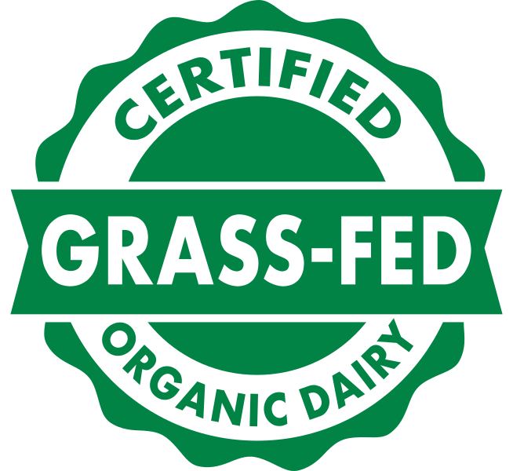
Organic Plus Trust (OPT)
Grass-Fed Organic Program Policy Addendum

Introduction

The Organic Plus Trust (OPT) Certified Grass-Fed Organic labeling program is an additional certification scheme for operations wishing to further describe and represent their livestock products as Grass-Fed. The program was developed by private industry wishing to further differentiate organic products with additional Grass-Fed label claims. Any operations wishing to market their products under the Grass-Fed Organic label must be certified to these standards. Oregon Tilth is accredited by Earth Claims LLC, as the OPT Program Manager to offer the Organic Plus Trust (OPT) Grass-Fed Organic Program.

OPT created the Grass-Fed Organic Livestock Program™ and a corresponding Policy Manual (together referred to as the OPT Program Manual) as a comprehensive set of standards under which certified organic livestock operations may be additionally certified as grass-fed. The program’s production requirements are intended to maximize the use of animal harvested forage in each animal’s diet, minimize grain in all forms, and maximize animal well being. The program is underpinned by the National Organic Program (NOP) and builds upon the existing federal oversight and standard requirements.

Oregon Tilth is accredited to offer certification to these standards for dairy and meat producers as well as handling and processing operations. This document is used in conjunction with the existing OTCO Procedures Manual to outline procedures for this program. This document is also supported internally through the OTCO Quality Manual to describe the overall quality system for certification services from OTCO. This document summarizes relevant details for OTCO from the OPT Program Manuals and does not constitute full requirements for certification under this program. For full requirements please download the OPT Program Manual: Certified Grass-Fed Organic Livestock along with the appropriate set of standards (Grass-Fed Dairy Standards or Grass-Fed Meat Standards).

Fees for Service
Operations applying for or renewing their OPT Grass-Fed certification pay an annual add-on fee to OTCO in addition to Organic certification fees. Inspection fees and expenses are billed at cost plus an additional 10% administrative fee, and will be separated out from the operation’s organic inspection costs for clarity in billing. Fees for the service are outlined below:

Producer Certification and Review: $350/year flat rate
Handling Certification and Review: $350/year flat rate
Annual Inspection: Billed at cost +10% admin fee

From the fees outlined above, OTCO transfers $150 per operation to Earth Claims LLC. as required under the program. Any operation wishing to use the Grass-Fed Organic seal should contact the OPT Program Manager directly for details on licensing the logo and licensing fees (which are reported and paid directly to OPT by the certified operation). To Contact the OPT Program Manager email rprickett@earthclaims.com

Standards
The criteria for certification to this scheme are detailed in the OPT Grass-Fed Organic Livestock Program Manual. Operators applying for meat or dairy production should carefully review the standards for Meat Animal Production and Handling Operations and the standards for Dairy Animal Production and Product Handling Operations, as appropriate to their operation. OPT is developing more specific standards for handlers under the OPT Program; these are anticipated to be completed in 2019. Until this time, the OPT specific handling practices must comply with NOP standards with regard to segregation/identity preservation and prevention of commingling and/or contamination.

The list below provides a summary of the requirements of the OPT certification program. Please be sure to review the full OPT Grass-Fed Organic Livestock Program Manual in detail.

General Requirements for All Operations
- Must be certified organic to USDA NOP standards by OTCO. If not already certified, Operations may seek USDA NOP and OPT Grass-Fed certification concurrently.
- Must be inspected annually, normally in conjunction with the organic inspection.
- Must implement sufficient segregation practices for the Grass-Fed supply chain and ensure prevention of contamination and commingling

Producer General Requirements
- Be certified by an animal welfare program approved by OPT - currently Farmers Assuring Responsible Management (FARM) is the approved program.
- Establish a minimum 150 day grazing season
- A minimum of 60% of an animal's dry matter intake (DMI) must come from grazing throughout the grazing season
- Maximize the use of animal harvested forage in each animal’s diet and reduce use of grain supplements
- Supplementation with specific feedstuffs, as identified in the Standard, when necessary to maintain nutritional stability and optimal rumen welfare.

Composition and Labeling
Labeling and composition requirements are outlined within the OPT Program Manual and further described below:

- Single ingredient products composed of dairy or meat produced or derived from animals on operations certified to this program shall be labeled: “Certified Grass-Fed Organic Dairy [product]” or “Certified Grass-Fed Organic Meat [product].”

- Multi-ingredient products containing livestock ingredients certified to this program requirements should labeled according to the USDA standards appropriate to the category and the placement of the above referenced labeling language shall be applied analogously to the use of the word “organic” under the NOP. See 7 C.F.R. §§301-305.

- If a multi-ingredient product is composed of 70%-94% ingredients compliant with this program it may be labeled “Contains Certified Grass-Fed Organic [ingredient described]” provided, the remaining content of the product must comply with organic requirements and in no case shall it contain the same ingredient certified to this program’s standard and a portion not certified to this program’s standard.

Program Seal Use
Use of the OPT Certified Grass-Fed Organic seal on any labeling, packaging or marketing materials other than the OPT Certificate, requires a completed and signed licensing agreement with OPT. A fee for use of the seal shall be assessed and collected from each certified operation that uses the seal on product packaging, labeling or point of sale information, except, certified operations selling less than $15,000 per year of combined products certified to this program’s meat or dairy standard shall be excepted from the assessment and collection of a seal-use fee. To use the seal and enter into a licensing agreement contact the OPT Program Manager at rprickett@earthclaims.com.

Certification Process
The certification process for OPT is generally identical to that set forth within the NOP Standards and NOP Guidance 2601 “The Certification Process”. All operations are required to be organically certified to the NOP as a baseline for eligibility in this program.

To request certification with OTCO to this standard as an addition to your organic certification the following process and document submittals will be required:
- Complete the appropriate addendum for your operation and have an Organic System Plan on file with Oregon Tilth. Livestock operations must complete the Certified Grass-Fed Organic Livestock Plan (OPT-L) addendum, and operations further processing (including on-farm certified handling and processing) livestock products must complete the Certified Grass-Fed Organic Product Plan (OPT-P).
- OTCO staff will review the completed addendum form and the Organic System Plan to confirm the Operations ability to comply with the Standard. Additional supporting documents may be requested. Once the application is fully reviewed and deemed sufficient OTCO will notify operations that they have been cleared for the next step of inspection. OTCO staff will communicate directly with you if the application indicates that your operation is not eligible for certification under this program.
- An on-site inspection will be conducted to evaluate the operation to the standards. All efforts will be made to schedule inspections to the OPT standards in conjunction with the normal mandatory inspections. In some cases this may not be possible due to inspector availability, timing and client needs. Operations interested in this additional label claim should contact OTCO with as much advance notice as possible in order to maximize the opportunity for combined inspections.
- OTCO will complete the final review of the inspection report and application documents for compliance to the standards.
  - If there are findings of noncompliance, a notice of noncompliance will be issued allowing for response and corrective actions. If there are major findings of noncompliance, a notice of denial may be issued.
- Certification – once all outstanding noncompliances have been resolved and any additional information needed has been provided, OTCO will issue a Certification Acknowledgement specifically to the Grass-Fed Organic Program.
- The OPT certificate and process is renewed annually along with the USDA NOP renewal. Renewing operations will need to indicate their desire to continue their OPT Grass Fed certification on their annual renewal update.

Variances from Program Standards
The OPT program will recognize variances from NOP organic issued by the US Secretary of Agriculture. If a variance is granted to requirements of the NOP, the same variance will be recognized under this standard. Only OPT may determine and issue a variance for this program that does not directly and unavoidably arise from NOP action.

Any operation certified under this program may petition the OPT program manager to grant a variance from any program standard. The petition for a variance should be submitted in writing and should be based on facts specific to that operation.
The OPT manager will prepare a summary of the request for submission to the program steering committee for review and decision. Variance requests require submission of clear and convincing evidence of the need for the variance. Petitioners for variance should consider the procedures and grounds set forth in NOP Guidance 2606 for assistance.

Exclusion of Milk or Meat from Disqualified Animals
To ensure milk or meat from disqualified animals does not enter the stream of commerce under this program’s Seal, three steps must be taken:
- Disqualified dairy or meat animals shall be immediately segregated from compliant animals upon receiving notice of their disqualification. Any milk should be immediately segregated and records maintained to demonstrate segregation.
- A disqualified dairy animal must thereafter depart from the certified operation within 7 days of receipt of the notice of disqualification. If a meat animal is disqualified, it may be retained and placed in a non-organic herd if there is a split operation.
- The milk segregation log, a signed statement verifying removal of the disqualified animal and identifying recipient of the disqualified animal should be submitted to OTCO not less than 10 days after the animal has left the operation.

Complaints
Any adversely affected person may file a complaint against any person or entity alleging the person or entity is misusing the OPT Seal or misrepresenting products in the marketplace. Additionally, a complaint may be filed if a person finds that OTCO has failed to uphold requirements of the program.

Complaints should be submitted to the OPT Program Manager in writing. Written complaints should be signed by the complainant and state the facts alleging the misconduct with sufficient evidence and information for investigation. Unsigned anonymous complaints will not be accepted by the Program Manager. To submit a written complaint to the OPT Program Manager Send via email to mailto:rprickett@earthclaims.com

Appeals of Adverse Actions
Appeals of adverse actions taken by OTCO under this standard shall be submitted in writing to the OTCO Certification Director. The appeal will be shared with the OPT Program Manager for decision. At the same time OTCO shall forward to the program manager any portions of the certification record necessary to the proper disposition of the complaint.
The following decisions are all appealable under these standards
- proposed suspension of certification
- proposed revocation of certification
- denial of certification
- combined notice of noncompliance and proposed suspension or revocation
- cease and desist notice
- denial of reinstatement

This above list is not exhaustive, and is subject to change.

