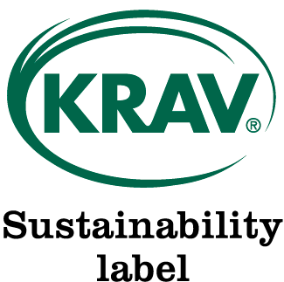In Sweden, consumers recognize the KRAV Sustainability Label as assurance that standards in addition to EU organic certification, including basic Social Responsibilities, are met. KRAV contracts with certifiers around the world to inspect EU certified clients to the additional KRAV Sustainability Label requirements. KRAV Sustainability Label Assessment is a Pilot Program to be reviewed and modified as needed. As a Pilot Program, OTCO has the option to refuse the KRAV service to clients where we feel we do not have the expertise or capacity to perform quality work. OTCO does not make a certification decision regarding the KRAV requirements. A completed copy of the KRAV Requirements Checklist will accompany the inspection report. The client owns the completed checklist and may provide copies to KRAV licensed customers who request it.

- KRAV Sustainability Label Assessment is dependent on certification to the EU Standards through OTCO’s International Market Assessment Program. Before applying please ensure that you are also either currently certified or applying for EU assessment.
- Operators may not use the KRAV-label, or state that the production is KRAV-certified. They may claim that KRAV´s extra requirements for products have been assessed.
- KRAV requires that each processor, co-processor and supplier with 10 or more total employees, regular and/or contracted, undergo the assessment.
- A separate KRAV Sustainability Label Request form (this form) must be submitted for each supplier and processor requiring KRAV inspection.

Operators applying for certification under EU standards need to enclose an additional US $500.00 per site requiring KRAV Assessment

Operation Name: |  | Date:

A. General Information
1) Have you read and fully reviewed the KRAV standards concerning social justice?
No | Yes
2) Have you included a KRAV Sustainability Label Request Form (this form) for each OTCO certified supplier or producer and processor that will be undergoing this assessment? Note: only operations with 10 or more total regular and/or contracted employees need to undergo this assessment.
No Yes Comments:

3) Please confirm that you are fully aware that you many not use the KRAV-label, or state that products are KRAV-certified. This assessment will provide you with a complete third-party checklist that you can supply to your customers.
Yes, I confirm I understand.
By signing below, you are stating that you are formally requesting this KRAV-Sustainability Label assessment and agree to undergo the additional verification by an OTCO inspector and be billed for this additional work. You are also agreeing to pay the $500 per site to be evaluated to receive this service.
Important Information Regarding Electronic Signatures: Oregon Tilth recognizes and permits the use of electronic signatures in the conduct of its business. By checking the box below, you willingly consent to the use of electronic signatures in the conduct of your business with Oregon Tilth.
AGREE
Name/Title |  | Date

Signature

